**HALF ADDER**

**EXP.NO: 21**

**AIM:**To design and implement the two bit half adder using Logisim simulator.

**PROCEDURE:**

1)      Pick and place the necessary gates.

2)      Insert 2 inputs into the canvas.

3)      Connect the inputs to the XOR gate and AND gate.

4)      Insert 2 outputs into the canvas.

5)      Make the connections using the connecting wires.

6)      Verify the truth table.   
  
**TRUTH TABLE:**

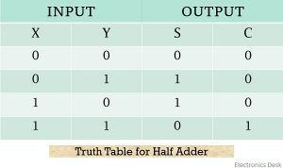  
  
  
S = A XOR B

 C = A AND B

**OUTPUT:**

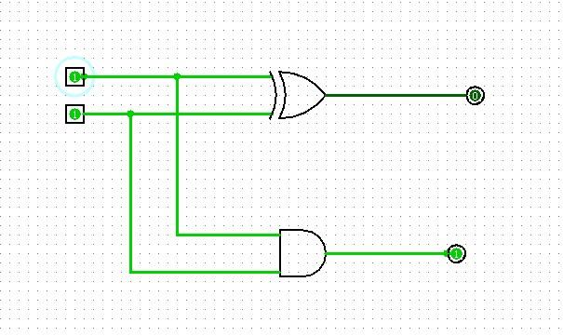  
  
  
  
  
  
  
  
**RESULT:**

Thus 2-bit half adder has been designed and implemented successfully using logisim simulator.